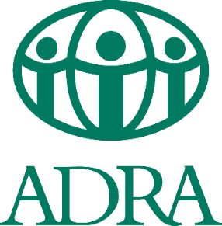

ADRA Sudan
Khartoum State
Khartoum Office
Khartoum Urban Women’s Empowerment Project

(KUWEP)

Request for Proposal (RFP)
Ref:00030- FY22
The closing date for the above-mentioned is by Sunday December 11th, 2022.
ADRA Sudan, on behalf of partners, is inviting a qualified consultant to lead and facilitate evaluation activities, focused workshops and lead data collection (focus group discussions and key informant interview) at field level. The evaluation is going to assess KUWEP project Khartoum Urban Women’s Empowerment Project and the final report will be submitted to ADRA Sudan.
ADRA Sudan hereby invites all interested and capable consultants to collect documentations, including Terms of Reference, and selection criteria, from link below.:
XXXXXXXXXXXXXXXXXXXXXXXX
The offers proposals are to be submitted to the following email address:
consultancy@adrasudan.org and copy(cc) programs@adrasudan.org
The closing date is on Sunday December 11th, 2022, at 4:00pm.
For any clarification or inquiries on this particular application, please contact the following number or email
0903719160 - Email: logistics@adrasudan.org /zaid.muhaied@adrasudan.org.

